
A 10
Set No : 2
Sreenidhi Institute of Science & Technology
(An Autonomous Institution)
Code No: 101MA01/111MA01

B. TECH. I – Year I – Semester Examinations, January, 2012 (Regular)
ENGINEERING MATHEMATICS – I ( Common to CSE, IT & ME)

Time: 3 Hours Max. Marks : 70

Note : No additional answer sheets will be provided.

Part-A (Objective Type)
Max.Marks:20

Answer all QUESTIONS.

1. Find the radius of curvature at (at²,2at) of the parabola y²=4ax.

2. Find the maximum and minimum values of 3x⁴-2x³-6x²+6x+1 in the interval (0,2).

3. Find the asymptote of the curve y²(a-x)=x²(a+x) parallel to y axis.

4. The curve y²(2a-x)=x³ is symmetrical about which axis.

5. Envelope of family of lines y=mx-a/m where m is a parameter and a is constant.

6. Prove that the matrix 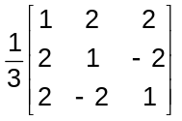 is orthogonal.
7. Find the eigen values of the matrix 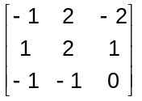
8. Evaluate 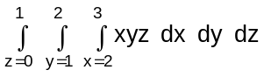.
9. Determine the nature of the series 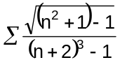
10. Verify Cauchy's mean value theorem for the functions e^{x} and e^{-x} in the interval (a,b).

Part – B
Max. Marks: 50

ANSWER ANY FIVE QUESTIONS. EACH QUESTION CARRIES 10 MARKS.

1. a) If A = 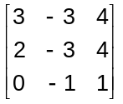, show that A³=A⁻¹.
b) Investigate the consistency of the following equations and if possible find the solutions.
4x-2y+6z=8; x+y-3z=-1; 15x-3y+9z=21

2. a) Show that the functions u=x+y+z, v=xy+yz+zx and w=x²+y²+z² are functionally dependent and find the relation between them if they are functionally dependent.

b) Find the radius of curvature ρ at any point of the cycloid x=a(θ+sinθ), y=a(1-cosθ). Hence find ρ at 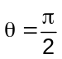.
3. a) Show that the radius of curvature at any point of the asteroid 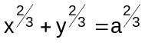, is three times the length of the perpendicular from the origin to the tangent at that point.

b) Show that the evolute of the cycloid x = a(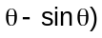; y = a(1-cos) is another equal cycloid.

4. a) Evaluate 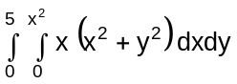
b) Evaluate 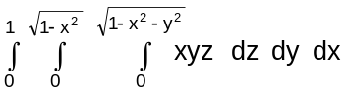
5. a) Find the characteristic equation of the matrix A = 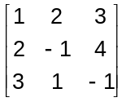 and hence verify Cayley - Hamilton theorem.
b) Using Cayley-Hamilton theorem find the inverse of 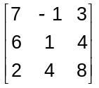.

6. Reduce the quadratic form 3x²+5y²+3z²-2yz+2xz-2xy to canonical form.

7. a) Test the convergence of the series
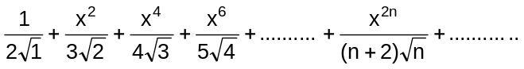.

b) If f(x)=sin⁻¹(x), 0<a<b<1, use mean value theorem to prove that 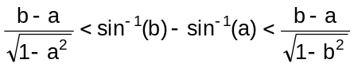.

8. a) If u = x²-y², v = 2xy and x = rcosθ, y = rsinθ then find 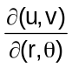.
b) A rectangular box open at the top is to have volume of 32 cubic ft. Find the dimensions of the box requiring least material for its construction.

-- 00 -- 00 --

